Dessert Menu
Freshly made

Homemade sticky toffee pudding 5.95

Apple & sultana crumble & custard 5.95

Warm Treacle tart with clotted cream 5.95

Mango, passion fruit & raspberry cheesecake 5.95

Kentish gypsy tart with cream 5.95

Crème brulee served with shortbread 5.95

Add Salcombe Dairy vanilla ice cream for £1.00

-------------------------------------------------------------------------------------------------------------------------------------------------

Salcombe dairy ice cream

1 scoop = 1.75 / 2 scoop = 3.50 / 3 scoop = 5.25
Choose from;
Vanilla, honeycomb, salted caramel, coconut,
Kenyan coffee, Belgium chocolate, Strawberry

Salcombe sorbet
Choose from:
Raspberry, mango or lemon

-------------------------------------------------------------------------------------------------------------------------------------------------

Cheese & bread board
Mini artisan loaves, chutney, celery & grapes
English cheddar, French brie,
Wensleydale & cranberry

For 1 person £6.95 / To share £12.50
Port
Grahams L.B.V 50ml - 20% - 3.55
Grahams Fine white 50ml - 19% - 4.00
Grahams 10yr Old Tawny 50ml - 20% - 4.50

Americano (black) 1.70
Flat white 1.95
Coffee
Cappuccino 2.50
Latte 2.50
Latte Macchiato 2.50
Espresso 1.70 English breakfast 1.95
Tea
Double espresso 3.20 Herbal 1.95
Decaffeinated 1.75 Decaffeinated 1.95
Floater 2.50 Hot chocolate 1.95
Liqueur Coffee 4.50
Choose from;
Baileys, Tia Maria, Rum
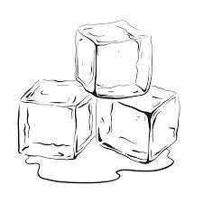
Cointreau, Jameson’s
After dinner
Over ice
Baileys 50ml - 17% - 3.50
Tia Maria 25ml - 20% - 2.45
Amaretto 25ml - 28% - 2.45
Limoncello 50ml - 27% - 4.00
Cointreau 25ml - 40% - 2.45
Cointreau Blood orange 25ml - 30% - 2.45

Single
Malt
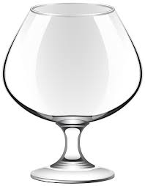
Laphroaig 25ml - 40% - 3.55
Glenmorange 25ml - 40% - 3.00
Jura 25ml - 40% - 3.55
Oban 25ml - 40% - 3.55
Brandy
Cognac
Martell VS 25ml - 40% - 3.55
Martell VSOP 25ml - 40% - 4.00
Martell XO 25ml - 40% - 8.00

Dessert
wine
Nederburg reserve
Noble late harvest 100ml - 11% - 5.00

Torres muscatel Oro 100ml - 15% - 4.00
Catalunya

