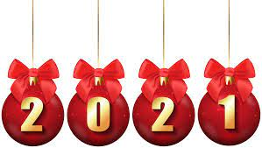
Christmas

Celebration Menu
December 1st to 24th
2 Course £18.95 / 3 Course £22.95

Starter
Spiced parsnip soup & herb croutons (v)

Prawn & crayfish cocktail (gf*)
Cinnamon, lemon, chilli mayo

Duck liver, orange & thyme parfait with fig chutney

Moroccan cauliflower roulade & chickpea chutney (v, vg, gf)

Main
Traditional roast turkey (gf*)
Roast potatoes, bacon wrapped chipolata, sage & cranberry stuffing

Baked salmon hollandaise with red currents & chives
With potato gratin dauphinoise & green beans

Sweet potato & red onion marmalade seeded tart (v, vg)
Roasted tomatoes

Barnsley lamb chop with mulled red wine cabbage
Minted new potatoes

All mains are served with a selection of season vegetables

Dessert
Christmas pudding & brandy sauce
Lemon & raspberry tart with clotted cream
Chocolate fudge cake & berry compote (v, vg)
Cheese board (gf*)

Gf= Gluten free, V= vegetarian, VG= Vegan

