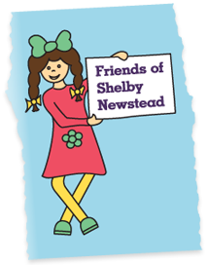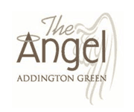

+ =

CHARITY QUIZ

**MONDAY 19th August**

THE ANGEL & The Friends of Shelby Newstead Team are pleased to host a Charity Quiz evening to help raise money for the children. *Test your General knowledge & Enjoy a Giggle*

Reservations from 6pm

Quiz Master ‘Sally’ From 7.00pm

**Team / Table of 4 £65 Chilli, Rice & Tortillas**

**Team / Table of 2 £32.50 Chilli, Rice & Tortillas**

*(Beef & Veggie 5 Bean Chilli, Tortilla Chips & Dips)*

***Winning Team Receive a Bottle of Whispering Angel Rose***

**PLEASE CALL: 01732 842117**

**Email: angeladdington@aol.co.uk**